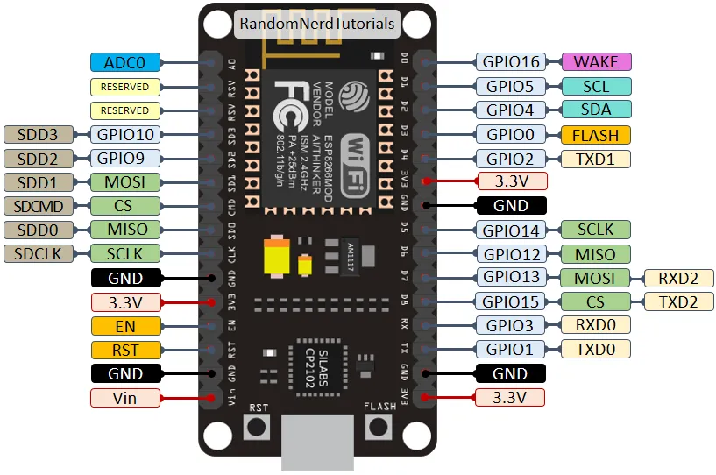

**16 X2 LCD**

VCC - connected VBUS(5V) pins on the ESP 8266

* Adjust the potentiometer to obtain the desired brightness.

GND- connected GND pin on the ESP 8266

SCL - connected D1 (GPIO 4) pin on the ESP 8266

* This is the Serial Clock Line that enables synchronization between the LCD and ESP 8266 during data transfer

SDA - Connected to D2 (GPIO 5) pin on the ESP 8266

* This pin carries data between the two devices, the LCD and ESP 8266§

**RFID-RC522 Reader**

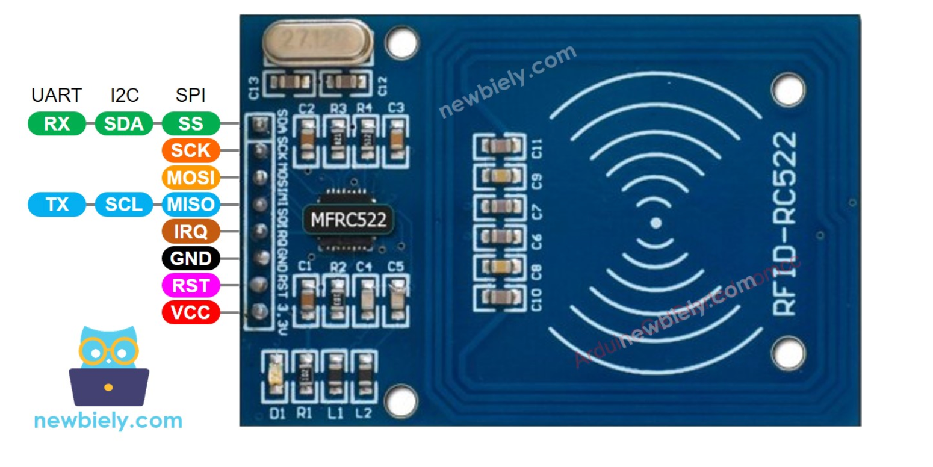

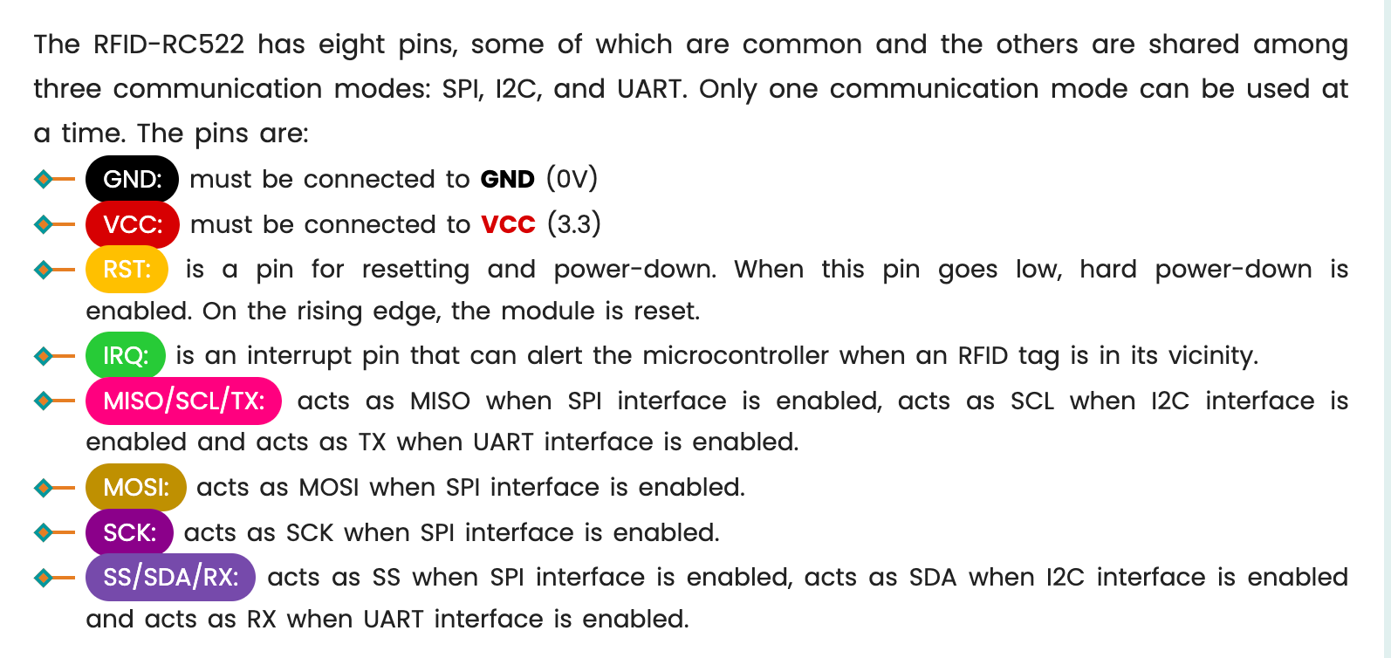

SDA-connected D8 (GPIO15) pin on the ESP 8266 —>

SCK-connected D5 (GPIO 14) pins on the ESP 8266

MOSI - connected D7 (GPIO 13) pin on the ESP 8266

MISO - connected D6(GPIO12) pin on the ESP 8266

IRQ - not connected pins on the ESP 8266

GND - connected GND pins on the ESP 8266

RST -connected D3 (GPIO 0) pin on the ESP 8266

3.3V - connected 3V3 pins on the ESP 8266

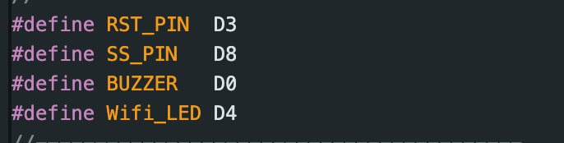

**PUSH BUTTON YES/NO**

* Connected between 3V3 and A0
* For determining the whether to record exit or not,

**Wifi LED:**

* Connected to pin D4
* Will blink when connecting to wifi, will be be repurposed when connected,

Two data points

<https://script.google.com/macros/s/AKfycbzeNSwA06slO2sQNLICf1AQpVA-1l9n8Qh9RluWWVumBFzhCSPgfGzSMhdVVn2xQSVupA/exec?name=>

**TO DO :**

* Modify the code so that it prints “Not Registered!” when the attendance fails to be recorded
* Modify the code so that when the Employee scans the card when leaving the office, it records the time they leave the office.
  + We will also need to use two push buttons to confirm if they scanned twice for leaving or to make sure attendance is registered.
  + We need to use the txt file for temporary storage when wifi is not working and for checking continuously if the employee has been registered for that day.
* Modify the code so that one employee is not recorded twice

<https://script.google.com/macros/s/AKfycbyXHiPdiKpxe-EvlN-rL9YVZVHfyJAD8DP_udKPiQNteayg2Xg_h8V1--6sO0lHXkeDtw/exec?name=>

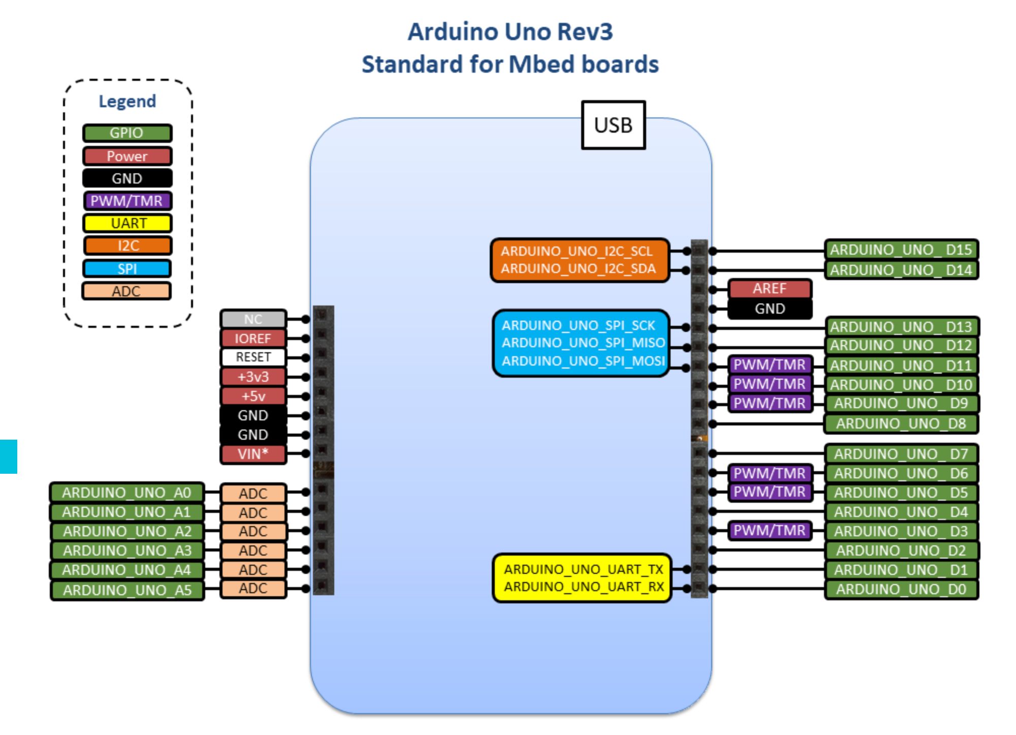

**Ultrasonic Sensor:**

VCC -> +5V

GND -> GND

Trig -> D11 (White)

Echo -> D12 (purple)

**Bluetooth Module**

VCC ->

GND ->

TXD ->

RXD ->

**16X2 LCD**

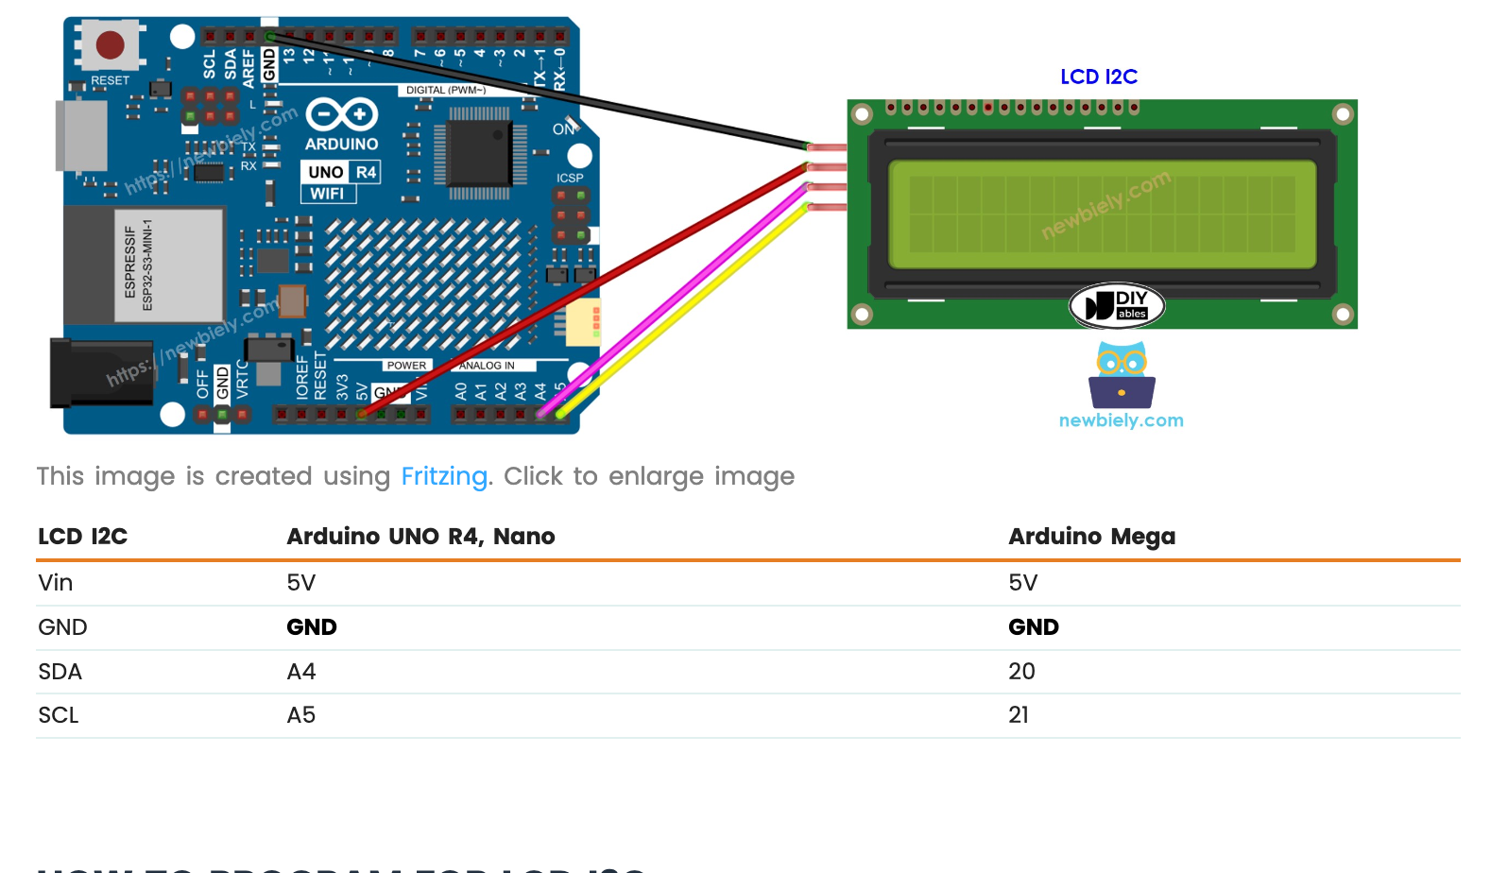

SDA - A4 - blue

SCL - A5 - Orange

**SD Card Module**

CS—---> 4

SCK—---> 13

MOSI —-> 11

MISO—-> 12

VCC —> 5V

GND —-> GND

**RTC Module**

VCC—-->5V

GND—-->GND

CLK—---> 5

DAT—---> 6

RST —---> 3